32.14: The intensity of the electromagnetic wave is given by Eqn. 32.29:
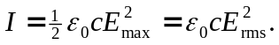Thus the total energy passing through a window of area during a time is

